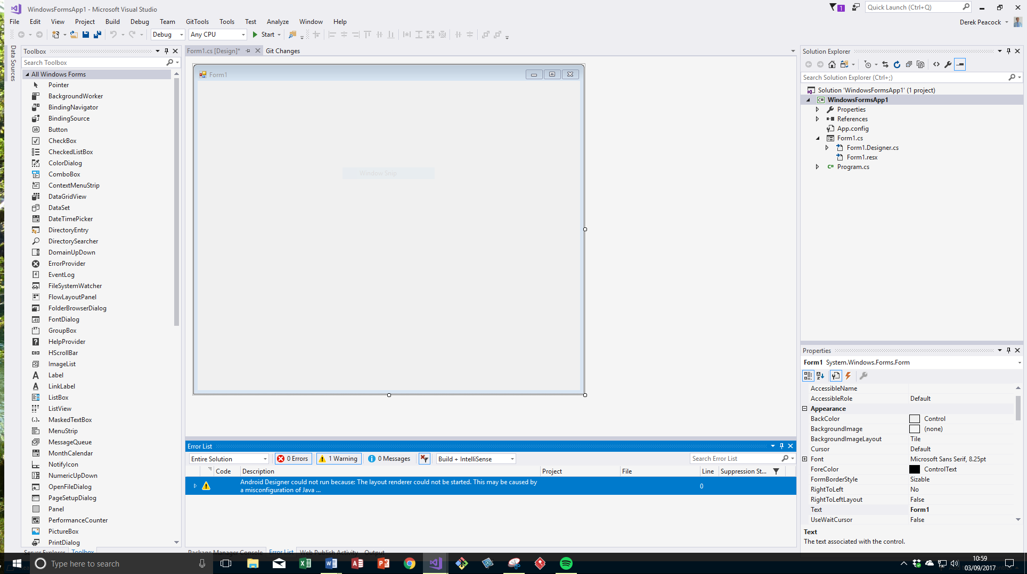

Event Driven Features
  - A report on the features of event driven applications and programming tools and techniques
Author: Dr Derek Peacock

Table of Contents
P1: Event Driven Programs 3
Graphical User Interfaces (GUIs) 3
Integrated Development Environments 3
User Interface Controls 4
User Interface Controls 5
Objects with Properties and Methods 5
P2: Event Driven Tools and Techniques 6
M1: Event Driven Operating Systems 7
Windows 10 7
P2/M2: Event Driven Tools and Techniques 7
D1: Event Driven non-Graphical Applications 7
Event Driven Cars 7
Event Driven Homes 7
Event Driven Businesses 7

P1: Event Driven Programs

Graphical User Interfaces (GUIs)
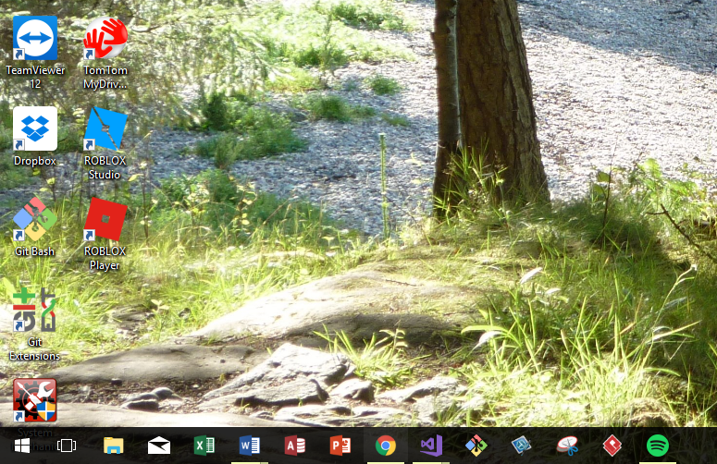

Integrated Development Environments

User Interface Controls

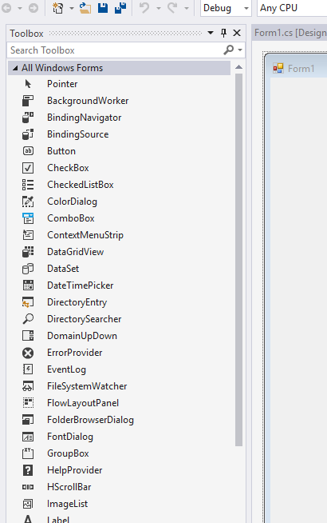

User Interface Controls
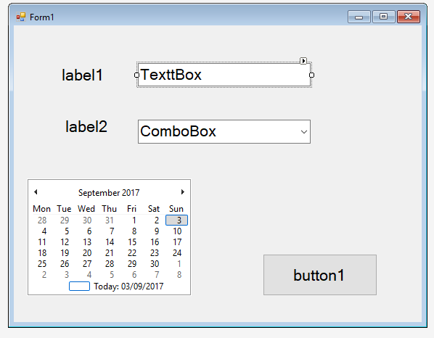

Objects with Properties and Methods
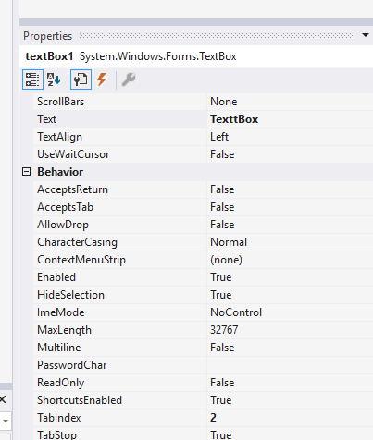
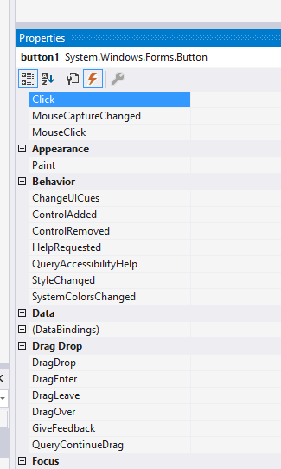

P2: Event Driven Tools and Techniques
Next week…

M1: Event Driven Operating Systems

Windows 10

P2/M2: Event Driven Tools and Techniques
Demonstrated next week….

D1: Event Driven non-Graphical Applications

Event Driven Cars

Event Driven Homes

Event Driven Businesses

