SQL - More easy-drinks queries

- Using the easy drinks table find the drinks that contain an ounce of soda? Write the query and the result below.

- Write the query for the following result.

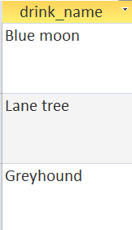

- Write a query which display the drinks with 2 ounces of soda?

- The above commands list the drinks with 1, 1.5 and 2 ounces of soda. Consider that the queries might miss drinks with amounts like 1.75. Rewrite the command to use greater than. Can you find the drinks which have more than 1 ounce of soda?

Comparison operator NOT EQUAL
<> not equal to
>= greater than or equal to
<= less than or equal to

- Can you write a query that displays all the drinks that begin with the letter L and any letters in the alphabet after L?

- Can you adjust the query to list drinks that begin with L but come earlier in the alphabet than M?

- Can you correct the following query? Then run the query and write the result below.
SELECT drink_name FROM easy_drinks WHERE
main=’orange juice’;
OR
SELECT drink_nameFROM easy_drinks WHERE main= ‘apple juice’;

Add a new column calories to the easy_drinks table.
drink_name | calories
Blackthorn | 33
Blue moon | 12
Oh my gosh | 35
Lime fizz | 24
Kiss on the lips | 171
Hot gold | 135
Lane tree | 17
Greyhound | 50
Indian summer | 30
Bull frog | 80
Soda and it | 19

- Write a query to find all the drinks which are between 30 and 60 calories. Your result should list the drink name and the calories, write the query and result below.

- Write the query which displays the following results.
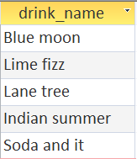

Add a new column calories to the easy_drinks table
drink_name | calories
Blackthorn | 33
Blue moon | 12
Oh my gosh | 35
Lime fizz | 24
Kiss on the lips | 171
Hot gold | 135
Lane tree | 17
Greyhound | 50
Indian summer | 30
Bull frog | 80
Soda and it | 19

- Write a query which finds the drink that are between 10 and 30 calories.

- Write the query that produces the following result.
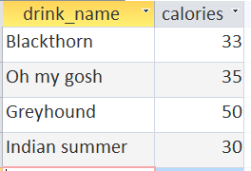
- Can you write the query that displays the drink names that begin with G and O?

