CO452 CeeBot Logbook
  - By Derek Peacock

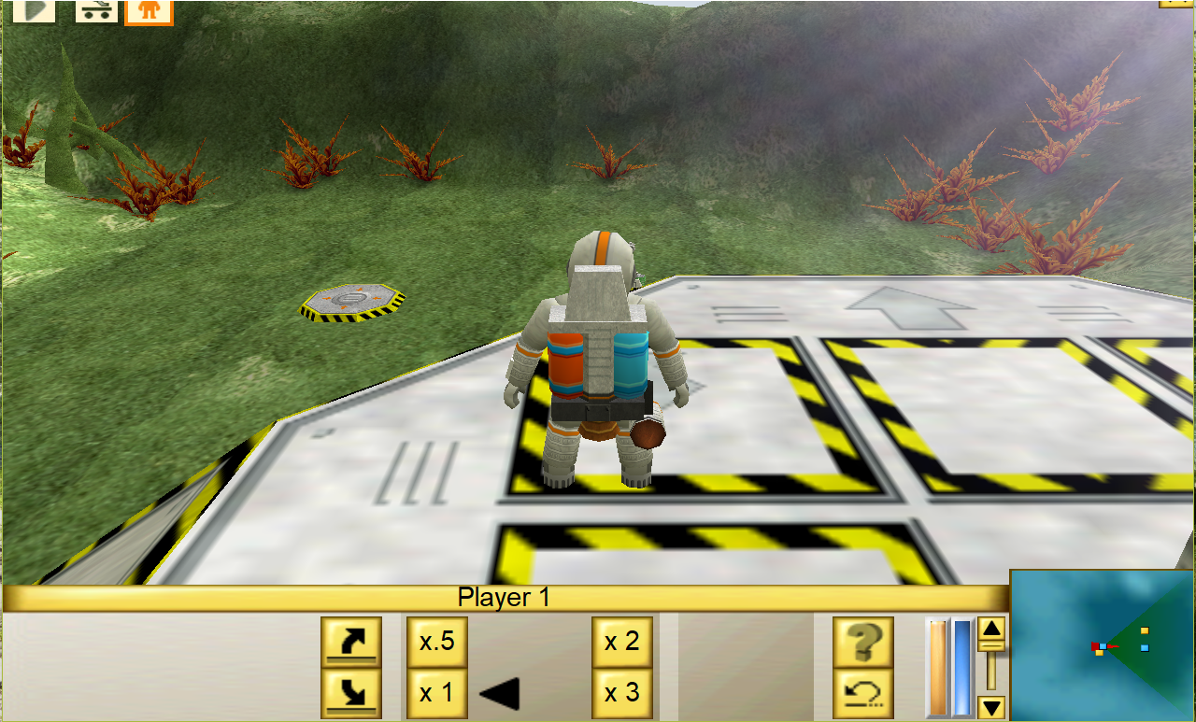

Logbook Contents
Task 1_3: Move and Turn 2
Program Description 2
Input-Output Diagram 2
List of Variables 2
Program Algorithm 2
Test Plan 2
Program Code 3
Screenshots 3
Task 1_4: Whatever 4

Task 1_3: Move and Turn

Program Description
Write a program in which the vehicle will move and draw and L shape 20 units by 20 units in blue

Input-Output Diagram
showing the user inputs and outputs for the program

Program

List of Variables
Identifier | Type | Meaning
size | int | Size of one leg of the L shape

Program Algorithm
- Select the blue pen
- Put the pen down
- Move 20 units
- Turn 90 degrees
- Move 20 units

Test Plan
Actual results are left blank at this stage and filled in after the program has been written.
Test No. | Inputs |  | Expected Outputs |  | Actual Outputs
1
2
3

Program Code
blue();
pendown();
move(20);
turn(90);
move(20);
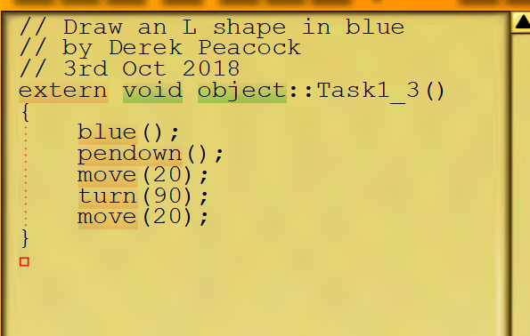

Screenshots
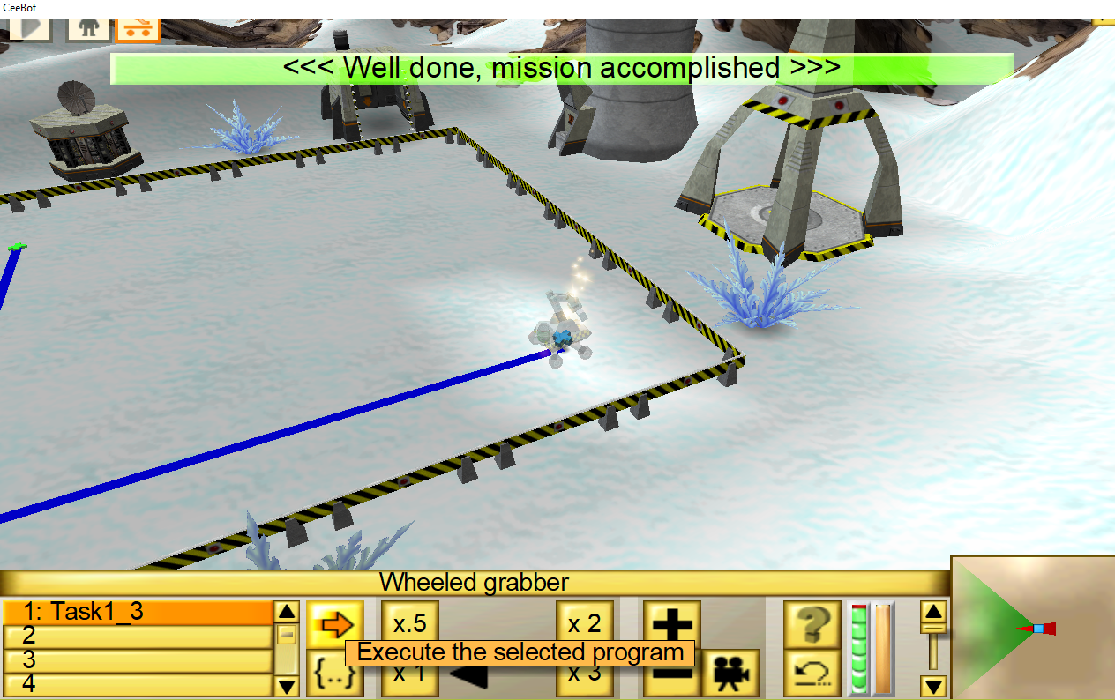

Task 1_4: Move an Object

Program Description
The vehicle must grab the titanium cube move to the platform and drop the cube

