P5: Black Box Testing
Function Tested | Test Data used | Expected Result | Actual Result | Initials & Date | Comments
MessageBox ShowInstructions | Run Game | Instructions Shown with game summary, keys used and scoring system | As Expected | DP 19/02 | It might be better if MessageBox appeared after run was selected
SandWorld StartLevel(1) | Click on Play | Message box is removed and all game objects appear in starting positions | As Expected | DP 19/02
Crab Move Left | StartLevel and then press Left arrow key when Crab has no object to the left | Crab moves left 5 pixels | As Expected | DP 19/02
Crab Move Right | StartLevel and then press Left arrow key when Crab has no object to the Right | Crab moves right 5 pixels | As Expected | DP 19/02
Crab Move Up | StartLevel and then press Up arrow key when Crab has no object above | Crab moves up 5 pixels | As Expected | DP 19/02
Crab Move Down | StartLevel and then press Down arrow key when Crab has no object below | Crab moves down 5 pixels | As Expected | DP 19/02
Collision with Rock | StartLevel and then try to move the crab over a Rock | Crab cannot move over a Rock | Crab can partly move over a rock | DP 19/02 | Not perfect but good enough to make the game playable
Energy Level decreases as crab moves | StartLevel and then continuously move the crab | The energy level of the crab decreases with each move of the crab | Cannot easily run this test! |  | Need to complete this test another way!
Speed of the crab decreases when energy level falls below 50% | StartLevel and then continuously move the crab | The speed that the crab moves per key press will be halved | Cannot easily run this test! |  | Need to complete this test another way!

M3: Testing Using Objects
One way of testing in Greenfoot is to use Objects directly. In this example a new Crab has been added to the start of a game. By right clicking on the crab the move method can be called. The crab does not move as no key was pressed, but you can inspect the contents of all the variables and constants (static fields) as shown below.
This test highlights an issue as in spite of the crab not moving its energy level has been reduced by one. This should only happen if the crab actually moves, and not if the move method is called without any movement taking place.!!!
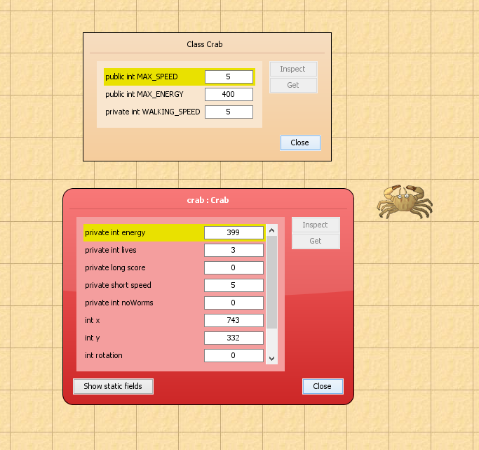

M3: Setting Breakpoints
In order to work out what is happening in the faulty crab move method a breakpoint can be set in the code by clicking in the left margin at the start of the method. The game can then be run and the execution will halt the first time the move method is called.
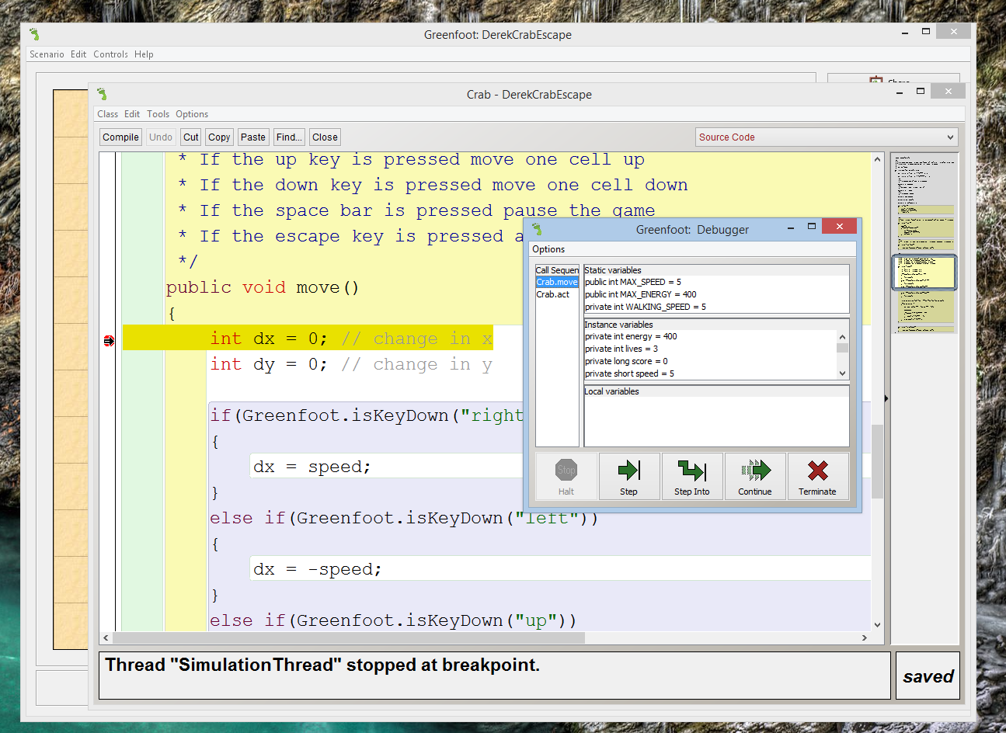
Execution has halted on the line that sets dx = 0, and in the debugger you can see that the energy lvel of the crab is correct at 400. You can then step through the code line by line.
When the program reaches the point which sets a new location for the crab, you can see that dx = 0, and dy = 0. This is because no key has been pressed so there is no need to reset the location of the crab, yet the code goes on to do exactly that, and also to decrease the crabs energy even though it has not moved!!!
In this case the code needs to be altered so that it does not try to move the crab if dx = 0 and dy = 0, and also does not decrease the energy value.
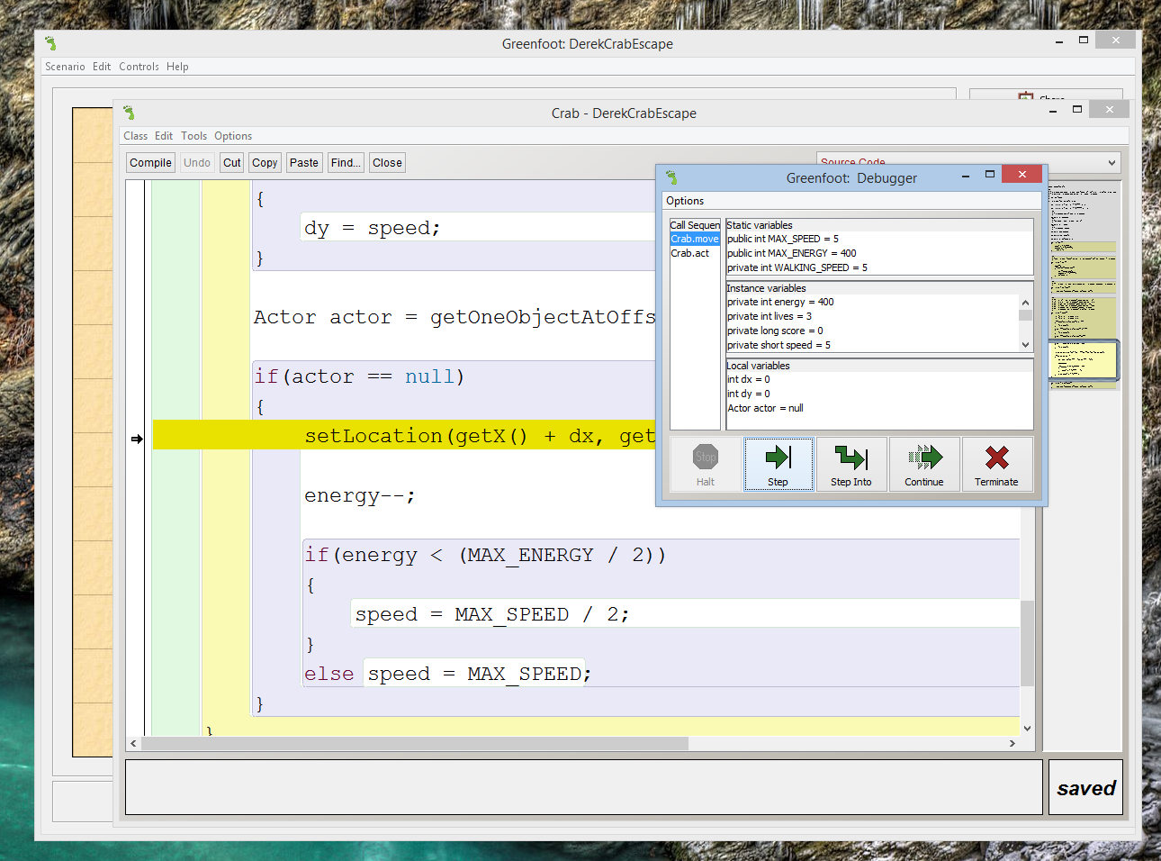
It is hard to see how this bug could have been found any other way, than by setting breakpoints and stepping through the code.

