The Crab Escape Game
  - By Dr Derek Peacock and Someone Else
P6: use appropriate tools to design a solution to a defined requirement

Summary: Crab Escape Game

Description
In this game the player moves a crab around the sand-scape trying to catch and eat worms that live in the sand and pop up from time to time from their burrows in the sand. Each time a worm is eaten the crab’s energy levels increases. Each time the crab moves its energy levels decreases. When its energy levels fall below a certain value, the crabs speed of movement decreases.
The purpose of the game is to progress to the end of the third level without being eaten by the otter. The otter loves to eat crabs, and searches for them largely using line of sight. It the otter sees a crab it will give chase. The crab’s only defence is to hide behind rocks, until the otter is distracted and loses interest.
The crab successfully completes a level if it eats all the worms in that level before being caught by the otter. The quicker the crab eats the worms, the higher the score.
If the crab is eaten, it can be re-generated three times per level, but its score is decreased each time it is eaten.

Proposed Platforms
The game is aimed at 7”-10” tablets running Android or IOS and with a minimal screen resolution of 1200 x 800 pixels

Proposed Timescale
- Week 1: Use Case Diagram
- Week 2: Use Case Specifications
- Week 3: Storyboard or Screen Layouts
- Week 4: Class Diagram & Data Types (M2)
- Week 5: Sequence Diagrams
- Week 6: Activity Diagram (D2)
Agreed Deadline: Group A: Wednesday 17th December or Group B: Friday 19th December

Use Case Diagram
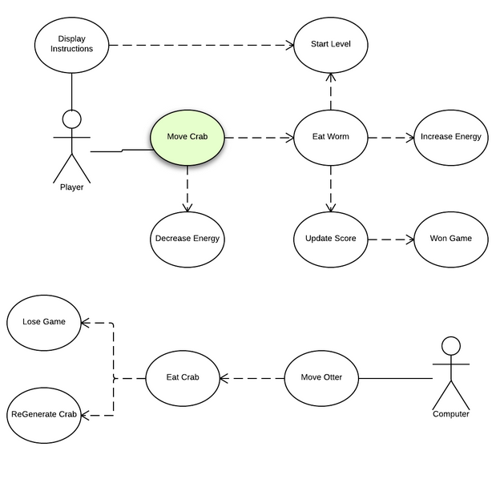

Use Case Specifications

UCS10: Eat Crab
Use Case Name: | Eat Crab | Author | Derek Peacock
Description: | When the Otter touches the crab, the crab is eaten and the player has lives left the crab is re-generated and the level re-starts. If there are no lives left, the game ends.
Pre-conditions | The otter touches the crab
Post-conditions | The level re-starts or the game ends
Normal Events | - The score is reduced  - If crab has more lives  - Lives are decreased by 1  - All points gained in that level are lost  - The level is re-started  - Else the game ends
Alternative Events
Screen Layout | 